1. Welcome Page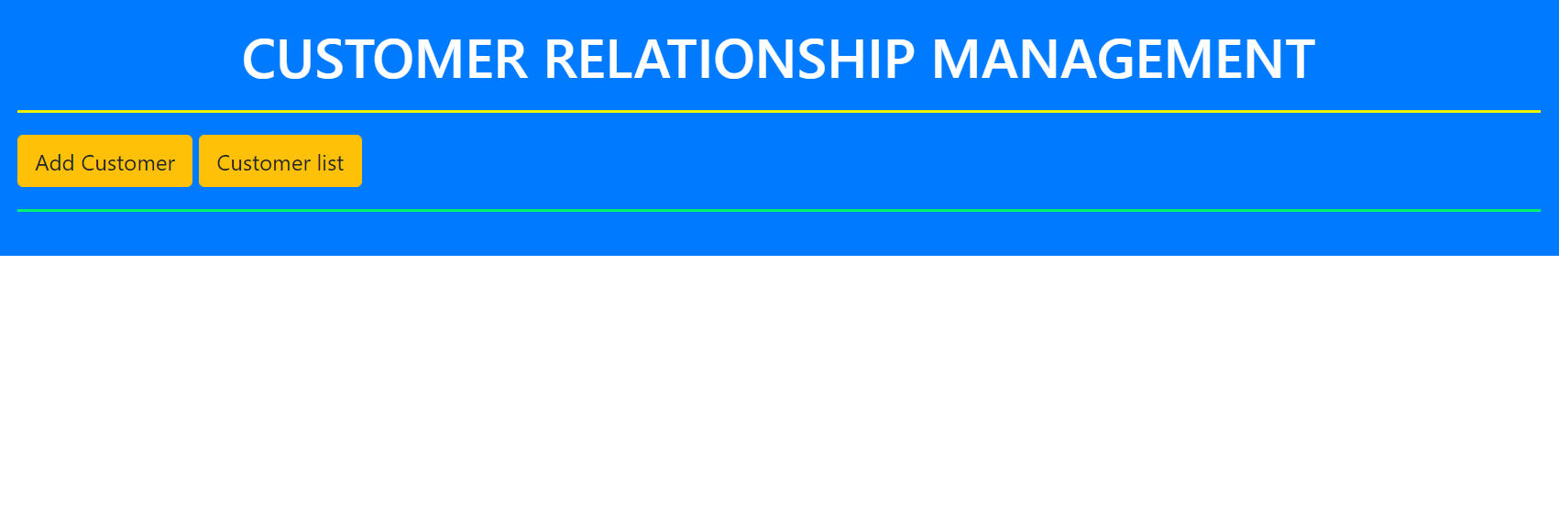
2. Upon Clicking Add customer buttonA picture containing graphical user interface

   Description automatically generated
3. Adding new customer valueGraphical user interface

   Description automatically generated with medium confidence
4. Upon clicking save button customer addedGraphical user interface, table

   Description automatically generated
5. Upon clicking update buttonA picture containing application

   Description automatically generated
6. Upon clicking back to listA picture containing graphical user interface

   Description automatically generated
7. Back to list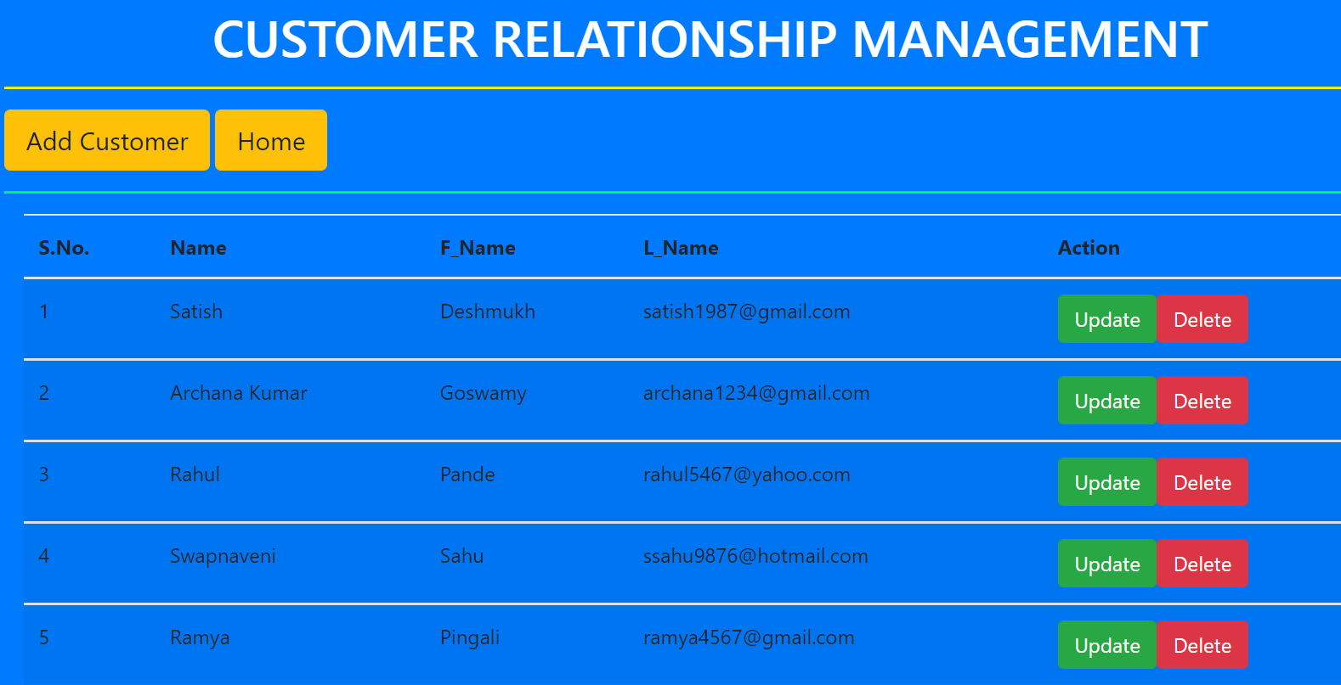
8. Updating customer dataA picture containing graphical user interface

   Description automatically generated
9. Upon save buttonGraphical user interface, application, table

   Description automatically generated
10. Upon delete buttonGraphical user interface, application, table

    Description automatically generated
11. Entry deletedGraphical user interface, application, table

    Description automatically generated
12. Upon clicking home buttonGraphical user interface, text, application

    Description automatically generated
13. Back to welcome screenGraphical user interface

    Description automatically generated with low confidence